**Graded Assignment 3 – ORM and Spring MVC**

**Question:**

You are required to create a **Customer Relationship Management** web application, where you will be developing CRUD (Create Read Update Delete) functionality.

Note the following points while developing the application

→ the main page will display all the customers present in the database.

→ Customers will have following attributes

a) First Name

b) Last Name

c) Email

The following are the screenshots of the pages opened on running the application **“CustomerRelationshipManagement”** depicting the functionality of the various pages of the application.

1. The below page is a **sample template of the main page.**

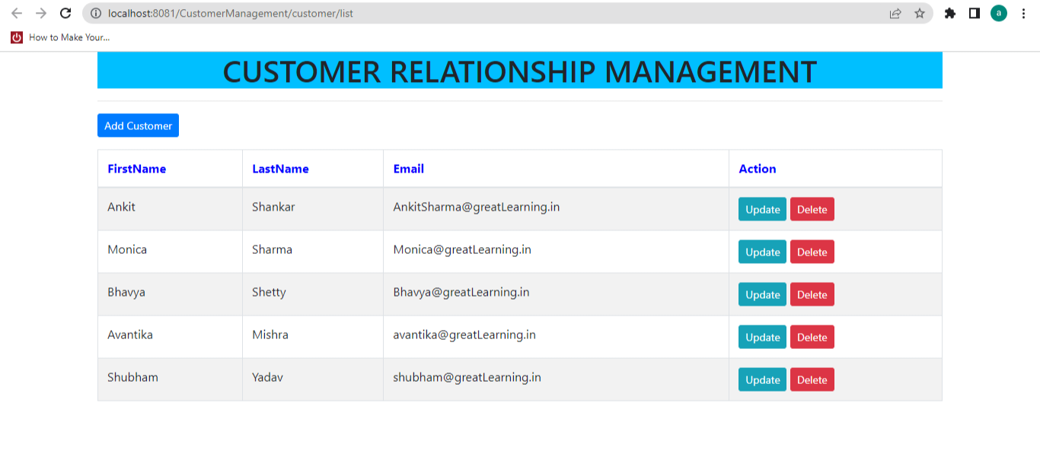

1. Upon clicking the “**Add Customer”** button, the user will be redirected to a new form-page, wherein the user will enter the details and save the customer.

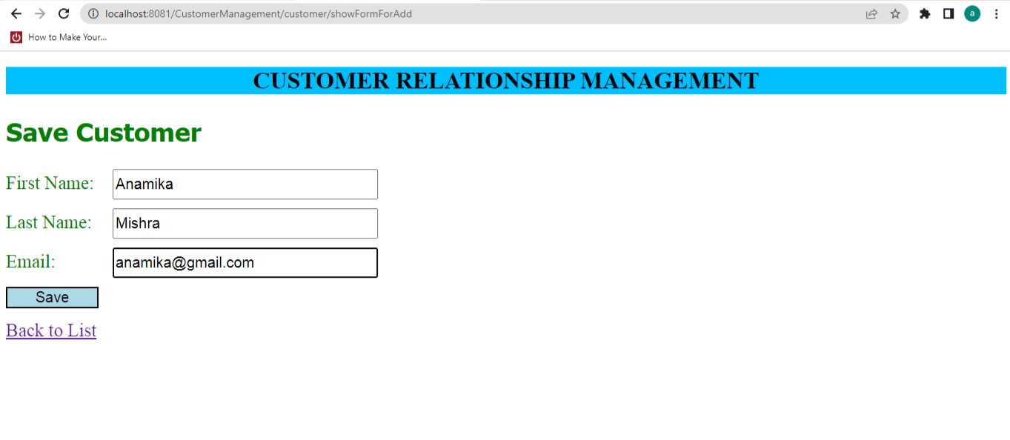

1. The user will be directed to the “main page” again with the **updated list of customers** after adding a new customer “Anamika Mishra”.

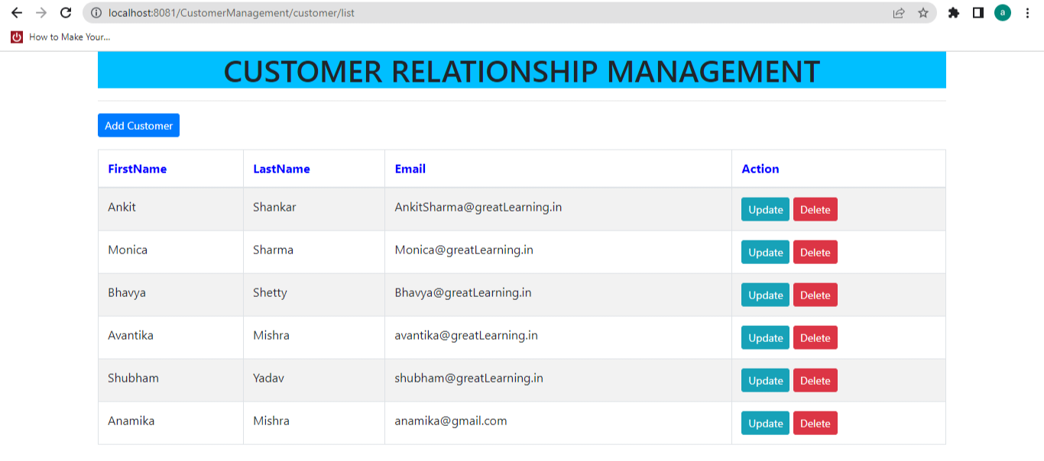

1. On clicking the “**update**” button in front of the corresponding user, the user can update the details of the customer.

The screenshot shows the updating of the email-Id of the customer “Bhavya Shetty” and saving it with the updated email as [bhavyashetty@greatLearning.in](mailto:bhavyashetty@greatLearning.in) rather than “Bhavya@ greatLearning.in”.

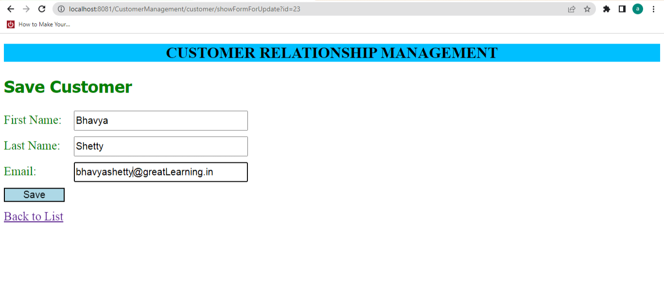

1. On confirmed updating, the user will see the **updated value of the Customer** “Bhavya Shetty” with the new updated email-Id “bhavyashetty@greatLearning.in”.

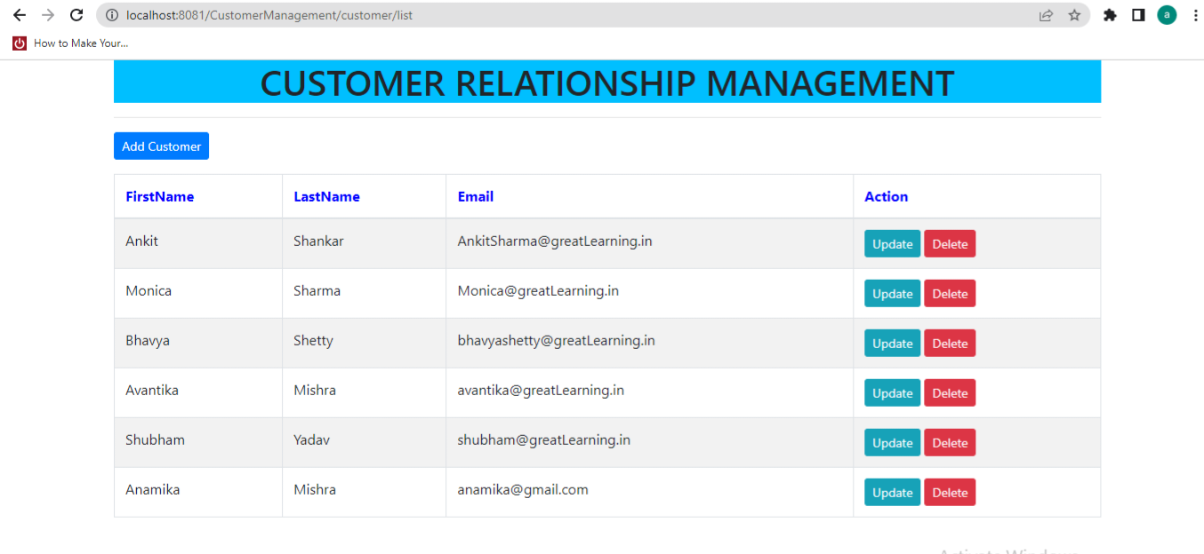

1. Upon clicking the **“delete”** button, a pop up is generated to confirm the action.

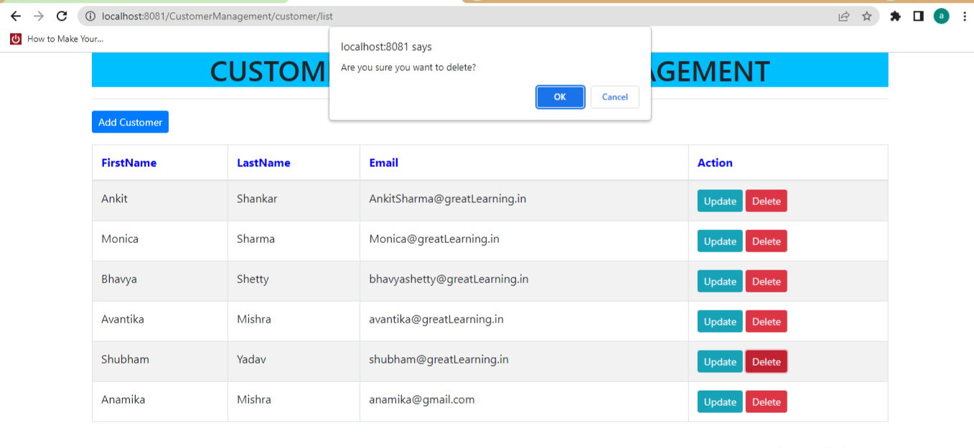

1. On confirming the action of deleting the customer, the user will see the **updated list of employees after deleting** customer “Shubham Yadav”.

